Curriculum Vitae
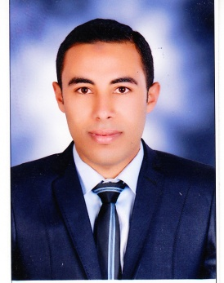
Moustafa Mohammed Moawad
Department of Theriogenology
Faculty of Veterinary Medicine
Assuit University
- Personal data:
Moawad Moustafa Mohammed
Last Name First Name MiddleName
01063482216
Mobile Phone

Permanent Address: Department of Theriogenology, Faculty of Veterinary Medicine, Assuit University.
Citizenship: Egyptian.
Place of Birth: Byla, Kafr El-Shiekh. Date of Birth: 10/10/1991.
Marital Status: Military service: Exempted.
E-Mail address: shasha_vet@yahoo.com

- Colleges and Universities Attended (in a chronological order):
University/School | Country | Obtained Degree | Graduation Date
Faculty of Veterinary Medicine. Assuit University. | Egypt | B.Sc. of veterinary medicine | 2014
Abo Badwy Secondary School. | Egypt | General secondary certificate | 2009
Abo Badwy Prep. School. | Egypt | Junior high certificate | 2006
- Employment History:
Employer | Position | Inclusive Dates
Assuit University, Faculty of Veterinary Medicine | Demonstrator | November 18, 2014
- Languages and computer skills:
Arabic | Speaking mother tongue | Readingexcellent | Writingexcellent
English | Speakingexcellent | Readingexcellent | Writingexcellent
France | Speakingfairly good | Readingfairly good | Writingfairly good
Computer Skills | Good | Microsoft Office (Excel, Power Point, Word, Access). | Photo Shop CS, Flash MX, Internet.

- Conferences, Training courses and Workshops:
- Participation with poster presentation in the First Annual Student Research Conference of Assuit Veterinary Student’s Scientific Association, Assiut University, Egypt.
- Participation as member of Student care Assuit Veterinary Student’s Scientific Association, Assiut University, Egypt.

- Teaching ,Scientific and applied activities :
- Sharing in treatment of obstetrics cases in the veterinary teaching hospital, Faculty of Vet. Medicine, Assuit University.
- Sharing in Diagnosis and Treatment Convoys in Assuit, which organized by Faculty of Veterinary Medicine, Assuit University.
- Participation in the teaching programs (practical part) for the students of third, fourth and fifth levels, Faculty of Veterinary Medicine, Assuit University.
- A membership of veterinary extension center, Faculty of Veterinary Medicine,Assuit University.
- Participation in summer practical training of final year’s students, Faculty of Veterinary Medicine, Assuit University.

